Zambia

## Freedom House political status

The data set shows the Freedom House political scores and status of the country each year.

## # A tibble: 19 x 5  
## country iso3c date mean status   
## <chr> <chr> <dbl> <dbl> <chr>   
## 1 Zambia ZMB 1996 4.5 Partly Free  
## 2 Zambia ZMB 1998 4.5 Partly Free  
## 3 Zambia ZMB 2000 4.5 Partly Free  
## 4 Zambia ZMB 2002 4 Partly Free  
## 5 Zambia ZMB 2003 4 Partly Free  
## 6 Zambia ZMB 2004 4 Partly Free  
## 7 Zambia ZMB 2005 4 Partly Free  
## 8 Zambia ZMB 2006 3.5 Partly Free  
## 9 Zambia ZMB 2007 3.5 Partly Free  
## 10 Zambia ZMB 2008 3 Partly Free  
## 11 Zambia ZMB 2009 3.5 Partly Free  
## 12 Zambia ZMB 2010 3.5 Partly Free  
## 13 Zambia ZMB 2011 3.5 Partly Free  
## 14 Zambia ZMB 2012 3.5 Partly Free  
## 15 Zambia ZMB 2013 3.5 Partly Free  
## 16 Zambia ZMB 2014 3.5 Partly Free  
## 17 Zambia ZMB 2015 3.5 Partly Free  
## 18 Zambia ZMB 2016 4 Partly Free  
## 19 Zambia ZMB 2017 4 Partly Free

## Freedom House classification of political change

The data set shows the GDP growth and the ecomic growth classification of the country each year.

## # A tibble: 19 x 4  
## country iso3c date politicalChangeFH  
## <chr> <chr> <dbl> <chr>   
## 1 Zambia ZMB 1996 no change   
## 2 Zambia ZMB 1998 no change   
## 3 Zambia ZMB 2000 no change   
## 4 Zambia ZMB 2002 democratization   
## 5 Zambia ZMB 2003 no change   
## 6 Zambia ZMB 2004 no change   
## 7 Zambia ZMB 2005 no change   
## 8 Zambia ZMB 2006 democratization   
## 9 Zambia ZMB 2007 no change   
## 10 Zambia ZMB 2008 democratization   
## 11 Zambia ZMB 2009 autocratization   
## 12 Zambia ZMB 2010 no change   
## 13 Zambia ZMB 2011 no change   
## 14 Zambia ZMB 2012 no change   
## 15 Zambia ZMB 2013 no change   
## 16 Zambia ZMB 2014 no change   
## 17 Zambia ZMB 2015 no change   
## 18 Zambia ZMB 2016 autocratization   
## 19 Zambia ZMB 2017 no change

## Freedom House score trend

The plot shows the Freedom House scores trend of the country.

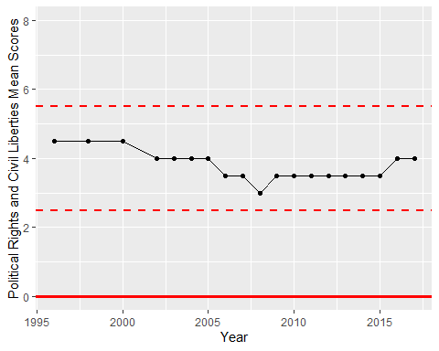

Freedom House Score Trend